**Tribun Pekanbaru, editorial 5 September 2020**

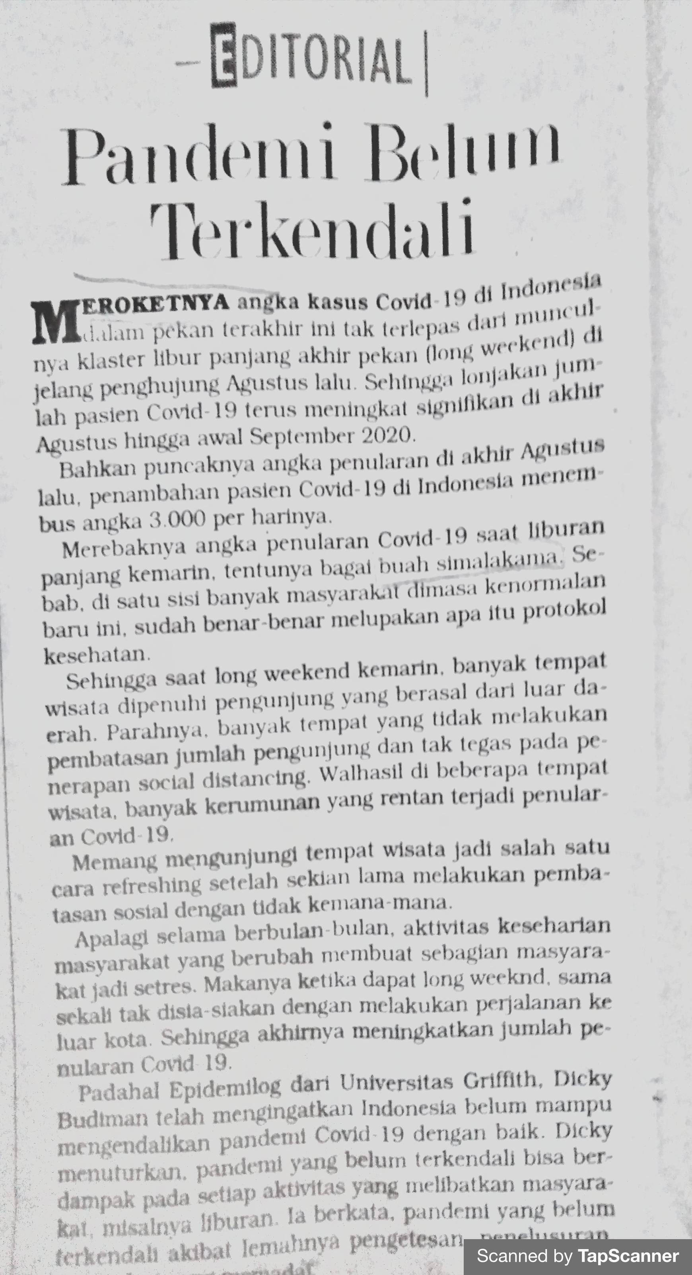

**Tribun Pekanbaru, editorial 8 September 2020**

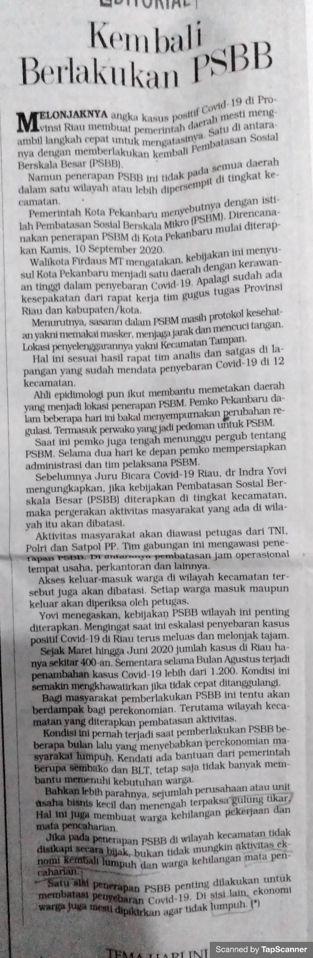

**Tribun Pekanbaru, editorial 9 September 2020**

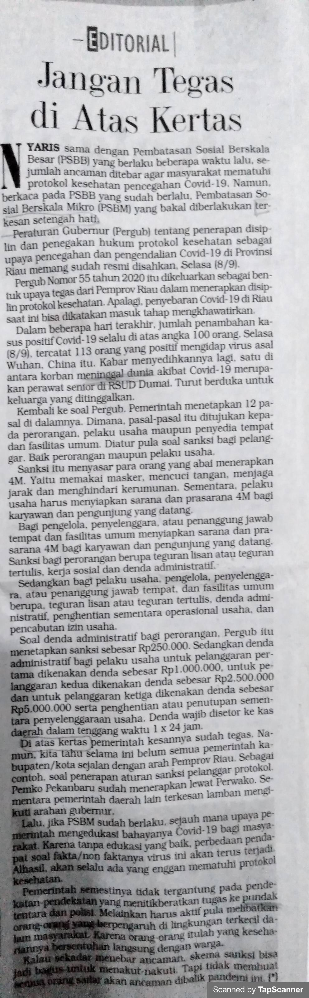

**Tribun Pekanbaru, editorial 10 September 2020**

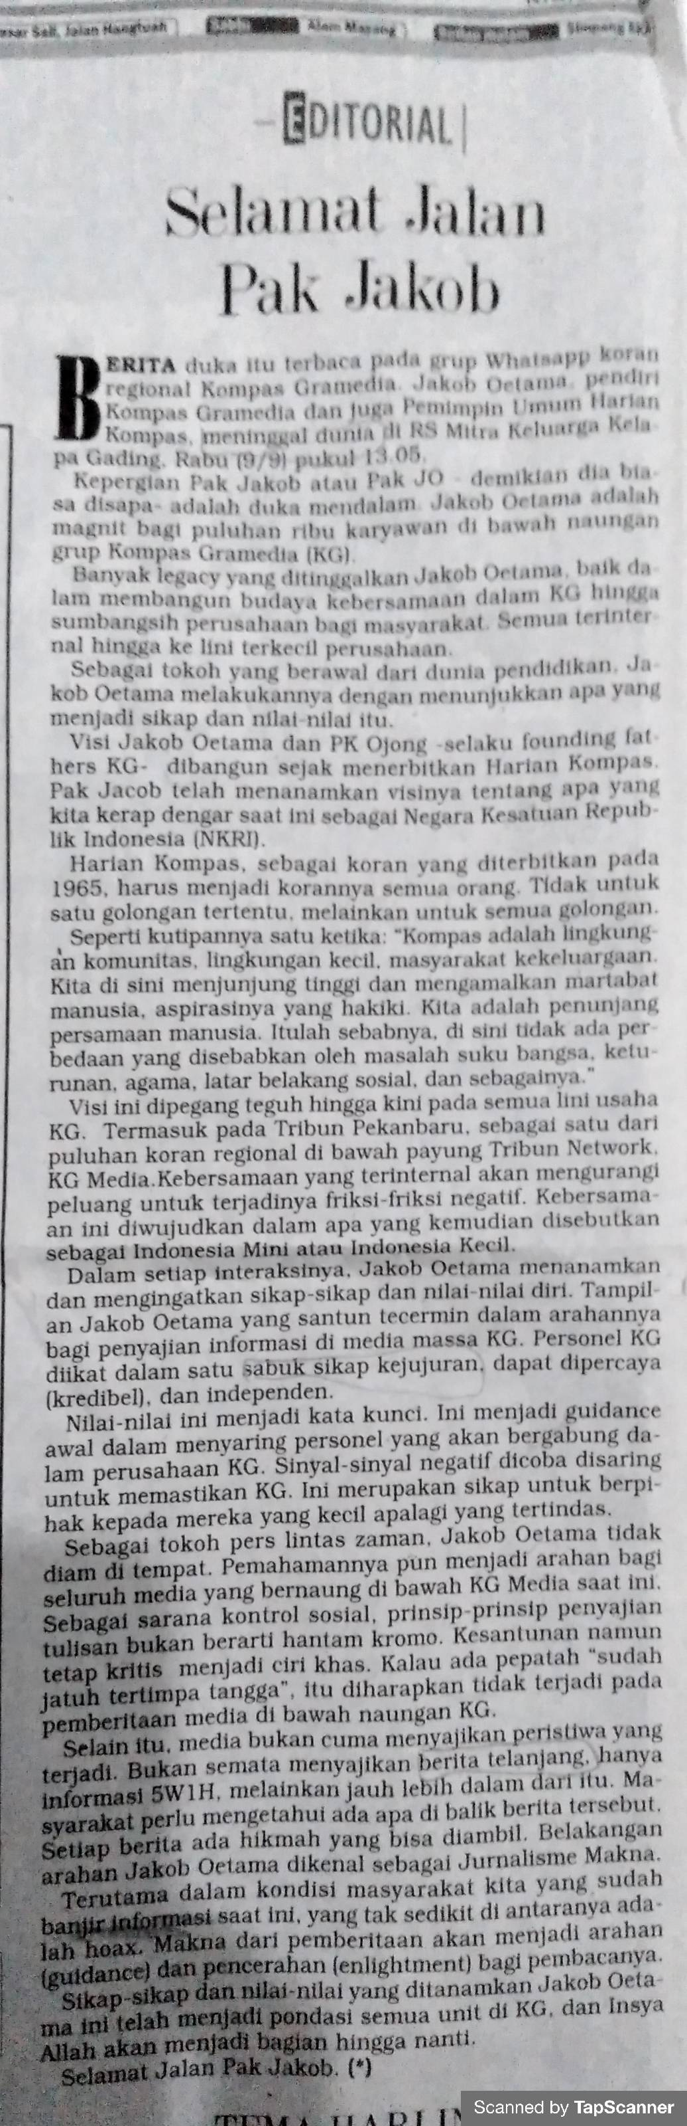

**Tribun Pekanbaru, editorial 11 September 2020**

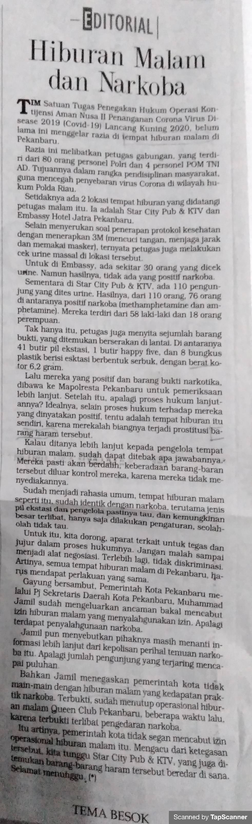

**Tribun Pekanbaru, editorial 15 September 2020**

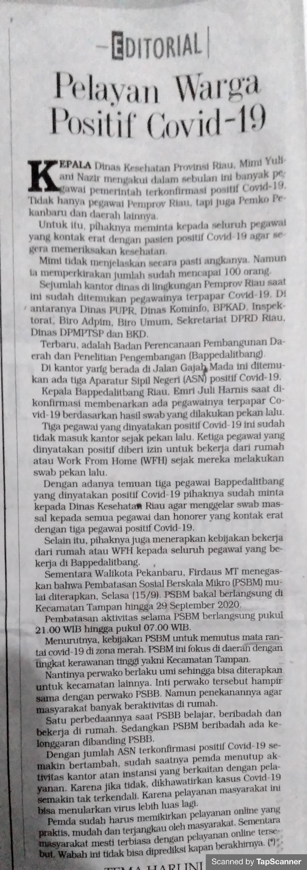

**Tribun Pekanbaru, editorial 16 September 2020**

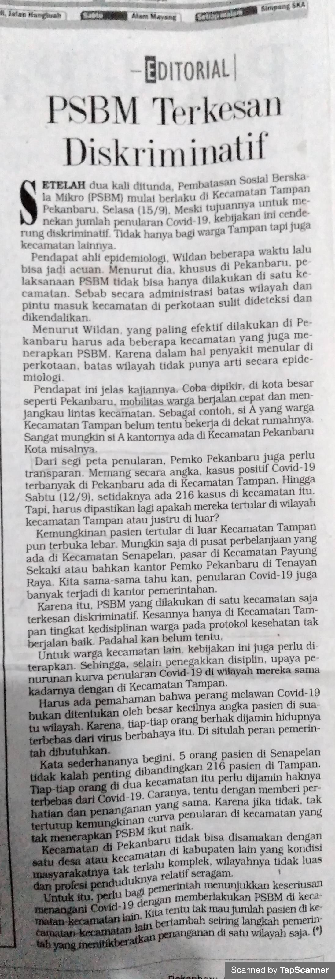

**Tribun Pekanbaru, editorial 17 September 2020**

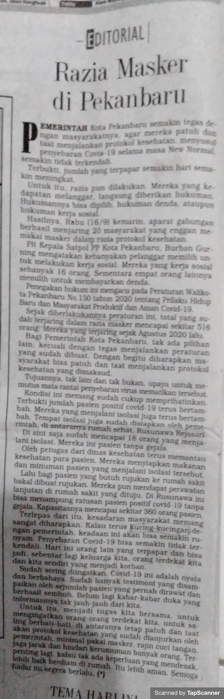

**Tribun Pekanbaru, editorial 18 September 2020**

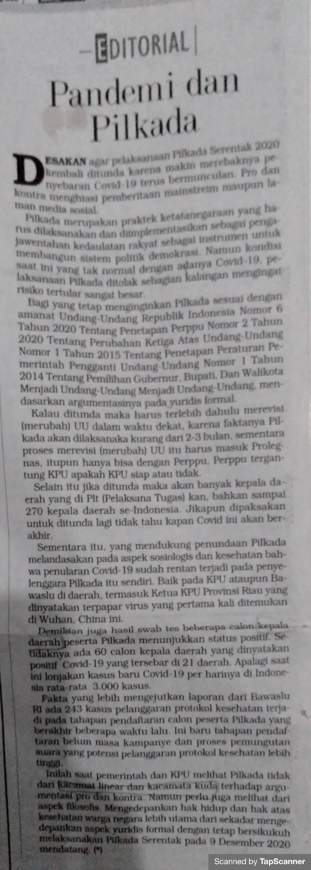

**Tribun Pekanbaru, editorial 24 September 2020**

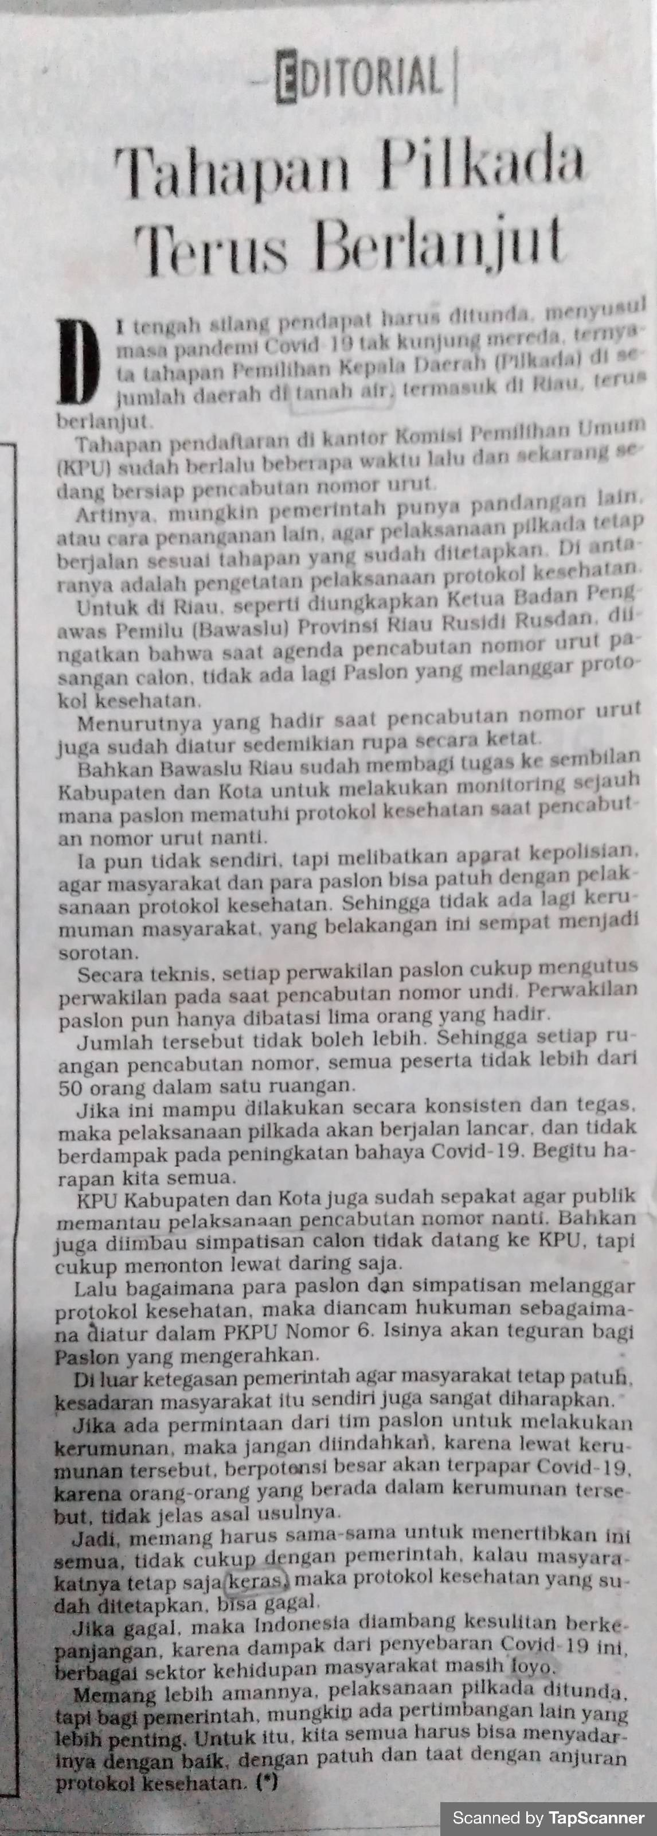

**Tribun Pekanbaru, editorial 25September 2020**

