**Get to Know Kompangan As Jambi Malay Traditional and Culture in Jambi Seberang**

1Abdullah Haidar, 2Evania Herindar, 3Fauziah Chairiyati

12Tazkia Islamic University College, Bogor, Indonesia

3Jambi University, Jambi, Indonesia

Email: [1abdullahhaidar027@gmail.com](mailto:1abdullahhaidar027@gmail.com), [2herindarevania@gmail.com](mailto:2herindarevania@gmail.com), 3[fauziahchairiyati.co.id@gmail.com](mailto:fauziahchairiyati.co.id@gmail.com)

**Abstract**

*The purpose of this research is to explain the history of Kompangan as a musical instrument and the roles of Ulu Gendong Group in preserving the Kompangan as traditional Malay arts in Jambi Seberang. By using anthropological research, the results of this study indicate that Kompangan art is Malay Islamic culture and traditional musical of Jambi Province especially from Jambi Seberang. Kompangan have been brought by immigrants from the Middle East. Sambilan Group was founded in Kampung Tengah, Jambi, and that is where Kompangan got its start. Kompangan art has evolved in several districts one of them in Ulu Gedong. Ulu Gedong, Riyatul Jannah, Riyatul Abedin, and Al-Hidayah are the four main compangan groups that make up from Ulu Gedong. Young generation play a crucial role in the preservation of Kompang in Jambi Seberang. The goal for the next generation will value their culture more and keep their cultural legacy alive, particularly this Kompangan art.*

*Keywords: Kompangan; Ulu Gedong, Traditional Art; Jambi Malay*

**Background of Research**

As the world's largest archipelago, Indonesia is home to a variety of ethnicities, languages, religions, and cultures. Regional culture is essential to the development of the Indonesian nation because it is an integral aspect of national identity. Malay Arab Culture in Jambi Seberang is one of Indonesia's regional cultures. This culture originated from Jambi Seberang community in the Jambi Province capital of Jambi City. Jambi City is the capital of Jambi Province and one of Jambi Province's municipalities. Jambi Province has 2 municipalities and 9 regencies. Geographically, Jambi City is situated between 00.45 degrees north latitude, 02.45 degrees south latitude, and 101.10 degrees east longitude.

The administrative territory of the Jambi City contains the oldest area which is located in Pelayangan and Danau Teluk. This district is located in the center of Jambi City on the northern side of the Batanghari river. Jambi's economic strategic area is located on the southern of the Batanghari river. On the south side is the official residence of the Governor of Jambi, a complex of offices, a complex of shops, and the Angso Duo market. Angso Duo market is the main market and the economic center of Jambi. The Opposite Area of Jambi City or Jambi Seberang describes the former Jambi city area prior to its relocation to the south side of the Batanghari river. Here the indigenous people of Jambi who adhere to the Arabic-Malay religious culture reside and flourish. Malay Arab culture is the result of a fusion of cultures introduced by Arab traders and native Malay people.

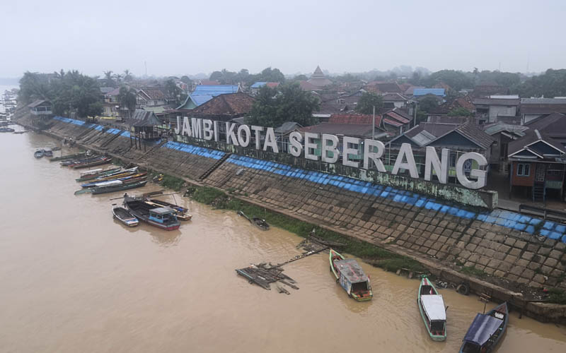

**Figure 1. Jambi Seberang**

The population of Jambi Seberang is a mixture of Arabs and Malays through marriage. In the past, many Arab merchants traded in this region. Jambi Seberang’s Arab-Malay religious culture is the result of interactions that continue to serve as a site to learn each other's cultures until they produce the religious culture. The name Malay Arab culture derives from the origins of this culture, which are Arab and Malay. Arab Malay religious culture in Jambi City manifests itself through a variety of community activities, including *Assyura* commemoration activities, *Nisfu Sya'ban* celebrations, *Burdah*, *Nginau, Nuak Ketan, Nyukur*, Grave Visitation, *Gambus*, *Zapin* dance, *Dana Syarah* dance, and *Kompang*. This Arab Malay religious culture embodies the values inherent in all activities. Importantly, the religious culture of Malay Arabs in Jambi Seberang is still being maintained by the community.

Due to the existence of various entities and communities, traditional art possesses unique characteristics and aesthetic value. It is believed that traditional art is one of the activities that combine the elements of physical exercise and enchantment for the benefit of the community. The supporting community views traditional arts as a link between ritual values and the concepts of simplicity and mutual cooperation.

Some of traditional industries have undergone cultural assimilation, particularly after absorbing Islamic influences such as kompangan. This is evident from the lyrics and instrumentation. The poetry is in the guise of a prayer from the *Barzanji* book, while the instrument is an Arabic tambourine. The community creates this art as an expression of their appreciation for all the blessings and gifts they have received, as well as a means of expressing their love and remembering the creator.

Similarly, the Malay inhabitants in Jambi Seberang have traditional arts that incorporate sound, singing, and music, such as kompangan, of which one can be found in Ulu Gedong, Jambi Seberang. Ulu Gedong Group owns one of the Kompangan that have persisted since their inception. Through perception and response, they have long held a connection to the existence of these traditional arts. The perceptions and responses of the supporting community to the existence of traditional arts can be viewed as a form of attitude, ideas, and the attribution of significance based on all of their knowledge.

The increasing difficulty of preserving culture, particularly traditional arts, is attributable to the progression of time and the current trends of globalization, which are causing numerous social changes in the pattern of people's lives, which in turn affect the culture of the people themselves. The regional culture of the ancestors' ancestry has began to be influenced by cultures from outside the region, and the culture of the region is gradually disappearing.

The existence of traditional art, which has been considered a cultural identity for those who support it and an expression of the supporting community's desire to create harmony between humans and their environment, must be demanded to compete openly with other cultural products. Therefore, it is necessary for the population to play a role and contribute to the preservation of traditional arts. Ulu Gedong group maintains the preservation of kompangan so they can compete with other traditional arts and are known for their participation in various significant events to promote them.

Base on research background, this research uses etnography method with a focus on cultural history which aims to introduce Jambi Kompangan as Malay traditional music to the community so that people will care about and preserve these local arts. Ulu Gedong group in Jambi Seberang are the cooperation partners. Besides that this study also aims to explain how is the acculturation of Islamic culture (development of Arabic-Malay religious culture) and the roles of Ulu Gendong Group in preserving the Kompangan as traditional Malay arts in Jambi Seberang.

**Research Question**

1. How is the acculturation of Islamic culture and the development of Arabic-Malay religious culture in Jambi Seberang?
2. How did the Kompang art and culture spread in Jambi Seberang?
3. What is the role of the Ulu Gedong Group in preserving Kompang culture in Jambi Seberang ?

**Literature Review**

Art is a component of culture and can be affected by both internal and external factors. There are a number of internal factors, including the individual's learning process, routines, and life experiences. While environmental and geographical factors influence external factors. The existence of a bond of solidarity in a community can contribute to the uniqueness of its art. Sedyawati (1986) argues that "art as one of the cultural activities of the people in their life is determined by the supporting community" Humans create various forms of art, including dance, music, and fine art. The level of a nation's civilization can be determined by observing its art or culture. Since art is a part of culture, it must be preserved and developed.

Additionally, there are traditional arts that undergo cultural assimilation, such as Kompangan art. The Kompangan is influenced by Malay culture and Islam. Kompangan is the acculturation of Arabic-Malay culture in Jambi Seberang (Kusuma & Aman, 2021) then spread to numerous province of Jambi regions. Kompangan is deeply rooted in the culture of the Jambian people. The Ministry of Education and Culture added Kompangan art to the list of Indonesia's intangible cultural heritage in 2012 (Registration Number: 2012002261). The Kompangan art that exists and flourishes in various regions of Jambi Province serves as a ritual facility, an educational facility, an entertainment or aesthetic facility, an economic facility, a communication facility, a tourism facility, a means of supervising the younger generation, and a means that can have a positive effect on the lives of many people, particularly the owners of art and culture from an ethnic group.

**Research Method**

This article's method is an anthropological one using a realism ethnographic perspective. A cultural phenomena is described in realist ethnography without the involvement of observers. This article was created based on participant observations, interviews, and literature reviews that took place in the Jambi Seberang. An ethnic group's overall ethnic culture can be described using the ethnographic method (Koentjaraningrat, 1998). The goal of ethnography is to pay attention to the significance of the events and behaviours that happen to the people whose behaviour we wish to understand (Spradley James, 2007). Ethnography is a technique that explicitly explains the social interactions, relationships, traits, and origins of a human group (Kamarusdiana, 2019). Using ethnographic techniques by monitoring patterns of behaviour, customs, and viewpoint on life through appreciation and research on the object under study, this method seeks to assess the condition of natural things that are focused on Arabic-Malay religious culture especially Kompangan and the role of Ulu Gedong in preserving the Kompangan as traditional Malay arts in Jambi Seberang.

**Result and Discussion**

**Islamic acculturation and the development of Malay Arab Religious Culture in Jambi Seberang**

One of the ethnic groups wealthy in culture and art in the province of Sumatra is the Malay ethnic group. Malay values are used as guidelines and teaching indicators in culture in the Malay art system. Customary institutions are an integral element of Malay art. Malay art contains a philosophy of life and conceptions about various things in culture, such as divinity, cosmology, globalization, acculturation, innovation, enculturation (Fariani, 2017). Islamic religious values are thoroughly held in the culture of the Malay people. This pertains to the majority of Malay people who are Muslims.

The Arabic Malay Religious Culture is a culture of the residents of Jambi Seberang. In the 15th century, Islam first entered and expanded throughout the Jambi region. Jambi's Malay cultural civilization, led by a Turkish merchant named Ahmad Salim, also known as Datuk Paduko Berhala (Pemeritahan Provinsi Jambi Dinas Kebudayaan dan Pariwisata Museum Sigenjai, 2019) was responsible for the dissemination and development of Islam in Jambi. In addition, Ahmad Salim married a Paguruyung descendant whose daughter Selaras (Pinang Masak). After Ahmad Salim's marriage to Putri Selaras Pinang Masak, Islam began to penetrate and flourish in Jambi.

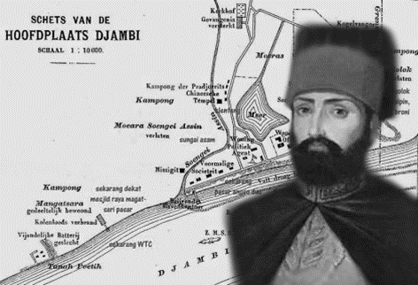

**Figure 2. Ahmad Salim or Datuk Paduko Berhala**

The Malay kingdom and the Jambi sultanate were then aware of the growth of Islam in Jambi. Since the Pamalayu voyage by the Singosari kingdom about 1275 AD, the Malay kingdom has been acknowledged. Then, in 1286 AD, Kertananegara (*king Singosari*) sent the Amoghapasa statue to the Malay kings Dhamasraya, Malayapura, and Pagaruyung. The Malacca Peninsula region contributes to dominating the crucial trade route on the East coast that connects Persia, India, Gujarat, China, Arabia, and the Archipelago. The Malay kingdom became one of the kingdoms in Indonesia. The development of relations with the outside world has had an impact on the fields of economics, commerce, culture, and islam.

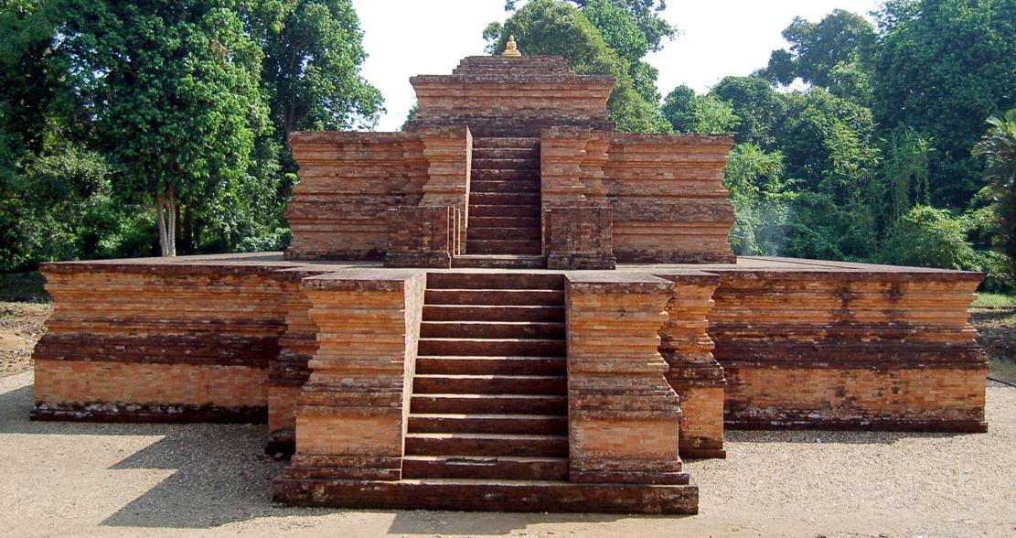

**Figure 3. Jambi Old Malay Kingdom Center**

The peaceful proliferation of Islam in Jambi allowed for Islam's rapid development. Ulama, Preachers, and *Kiai*, who travel to Mecca Al-Mukaramah to study, continue to advance the propagation of Islam. This also plays a significant role in the dissemination and development of Islam in Jambi

During the Jambi sultanate, a region known as Jambi Seberang became the commercial hub. This region is Jambi's commercial economic center. Additionally, this region is a center for the propagation of Islamic culture and religion. Over time, the area on the opposing side of Jambi City has developed its own civilization and culture. The interaction between the native Malay inhabitants of Jambi City and Arab merchants in particular resulted in a blending of cultures. Until Jambi City generates a new culture, which is known as the Arabic-Malay religious culture. In addition, the Arabic-Malay religious culture remains an integral part of the Jambi Seberang Community's way of life.

Arab Malay culture with *Assyura* commemoration activities, *Nis'fu Syaban*, *Burdah, Nginau, Nuak Ketan, Nyukur infant* and Grave Visitation, the city of Jambi produces an immaterial culture. In addition, it is manifest in *Gambus* music performances, *Zapin dance*, *Dana Syarah dance*, and Kompang.

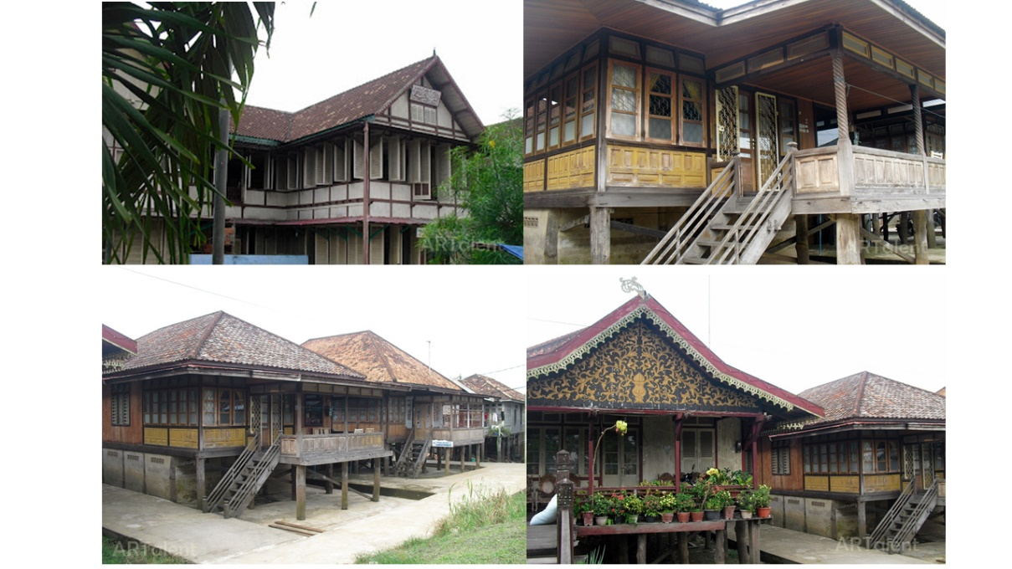

**Figure 4. Village in Jambi Seberang**

The strong influence of Islam across the city of Jambi (Jambi Sebrang) has also grown many pesantren. There are Islamic boarding schools that have been established since the early 20th century AD. These Islamic boarding schools were pioneered by figures from the Tsamaratul Insan Association, a social organization by Jambi clerics which was inaugurated by the Jambi State Resident No. 1336 on September 10, 1915.

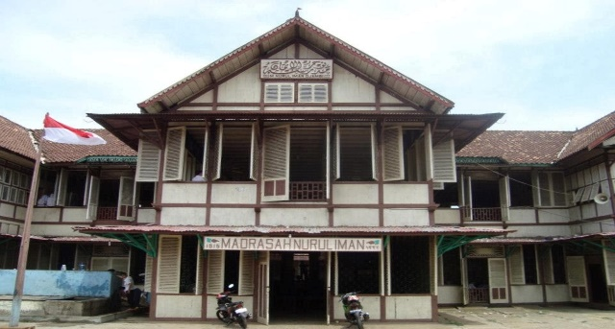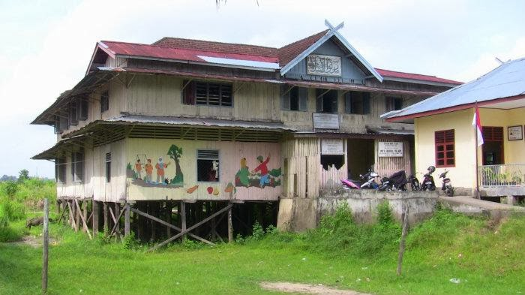

**Figure 5. Islamic Boarding Schools in Jambi Seberang**

The 11 Islamic boarding schools include the Nurul Islam boarding school founded by K.H.M. Saleh in 1922 in Tanjung Johor, the Nurul Iman boarding school founded by H. Ibrahim bin H. A. Majid in 1915 in Kampung Tengah, the Aljauharen boarding school founded by H.A. Majid in Tanjung Johor in 1922, and the Saadatur Daren boarding school founded by H.A. For the residents of Seberang Kota Jambi, education is a means for educating the nation's future Consequently, Seberang Kota Jambi is also known as the city of students.

**Kompang Melayu Art and Culture in Jambi Seberang**

Kompangan is a prominent artistic tradition with Islamic overtones among the people of Jambi Seberang. The philosophy underlying Kompang art is one of religious and artistic harmony. Kompang is an art form that facilitates the spread of Islam, integrating and harmonizing the spread of Islam through art. Kompang combines the tambourine instrument with the recitation of poetry and adoration of Allah SWT and Muhammad SAW. Kompang can be used as a culturally-sensitive means of propagating Islam. Kompang, in addition to serving as a form of art, can also serve as a way for citizens to remain in touch and develop closeness. Because there is a process of interaction and communication during this Kompang activity.

Kompangan is a media practiced by the people of Jambi Province as an expression of gratitude, a manifestation of affection for all the gifts and graces they have received, and a reminder of the Creator's power. The Islamic influence in Kompangan art is evident in the poetry and musical instruments employed. The poetry of Kompangan incorporates *sholawat* from the book Al Barzanji. In the meantime, the instrument employed is an Arabic tambourine (Karmela, Heidi, Yanto, & Aprilia, 2021).

The art of Kompangan has developed and spread throughout the Malay region, particularly in the province of Jambi (Fajriah & Wimbrayardi, 2020). Originally known as Hadrah, Kompang existed before Indonesian independence, which is estimated to have occurred in the 1930s. This Kompangan art is still practiced today (Suaibatul, 2021). Kompangan art is still a component of Hadrah art, which has been acculturated by the Malay Muslim community and has become a defining characteristic of Jambi Province's art. This Kompangan art will be used for a variety of Malay cultural events. This Kompangan art has spread throughout the province of Jambi and has begun to form small organizations. This Kompangan group is distinguished by its uniforms, accessories, and dance routines.

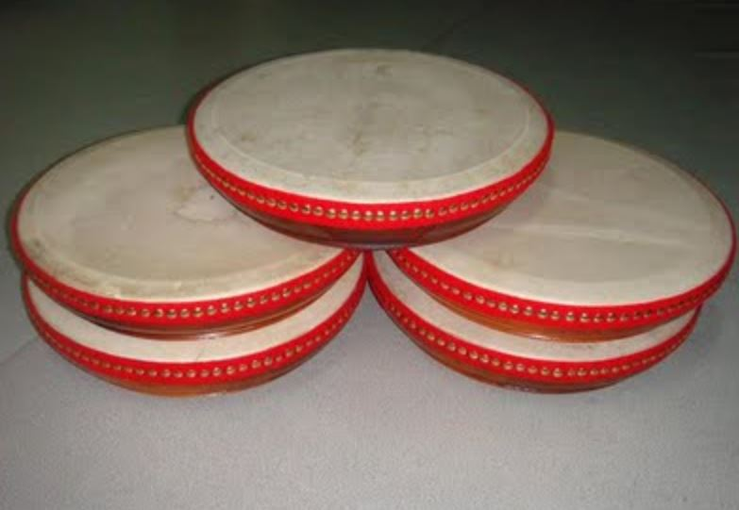

**Figure 6. Kompang Musical Instrument from Jambi Seberang**

In the province of Jambi, Kompangan art serves as ritual, educational, entertainment or aesthetic facility, economic, communication, and tourism facility, a means of supervising the younger generation, and a means that can have a positive impact on the lives of many people, particularly owners. The art and culture of a country.

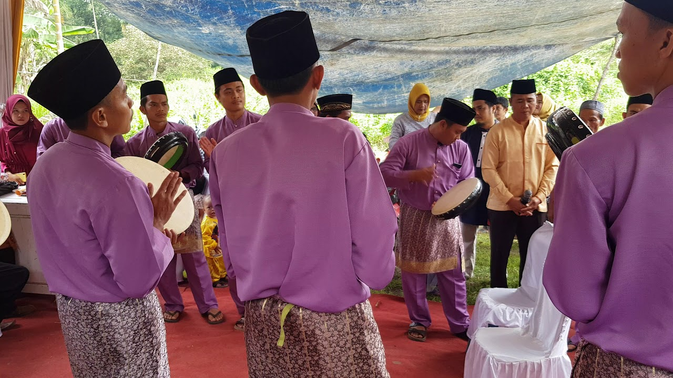

**Figure 7. Wedding Ceremony Accompanied by Kompang Musical Instruments**

Kompangan is traditional music from the province of Jambi that combines Islamic traditions and Jambi Malay dance with a tambourine-shaped percussion instrument. Aprilia (in Karmaela et al., 2021) contends that Kompangan begin with the musical instruments, songs, performance moments, number of players, costumes, accessories, and dance movements. Kompang is played with the soles of the hands and not with sticks or other percussion instruments. In the Kompangan performance featuring the Kompang instrument, additional musical instruments, such as *Jidor* or miniature drums, are used to make the procession more diverse and vivacious. Kompangan performances feature eight to twenty men performing specific blast patterns on Kompang musical instruments.

Kompangan art uses of Belango Bay attire, songket cloth or a sarong for head ornamentation, a black skullcap, a Kompang musical instrument similar to the Rebana, and a song based on a *Sholawat*. Kompangan consists of two elements: dance and music or singing that recites the *Sholawat* of the Prophet. Mahendra contends in Karmaela et al. (2021) that kompangan in the form of dance is typically the work of dance creators. Generally, Kompangan art is used to enliven Islamic-themed events such as the Prophet's Birthday, Isra' Mi'raj, thanksgiving, and marriages to accompany the groom to the bride's home. The Jambi Malay community is familiar with and has long practiced Kompangan art.

**The role of the Ulu Gedong Group in preserving Kompang Culture in Jambi Seberang**

The Kompang is categorized as a membranophone and is categorized under the drum instrument. Kompang has become a cultural tradition that has been handed down from generation to generation among the people of Jambi. Middle Village, Serpong District, Jambi Seberang was the initial location of Kompangan. Specifically, Kompangan began in 1943 with the formation of the Sambilan Group in the Sekoja Area of the Kampung Tengah Village area in the Danau Teluk District of Jambi City. While in the form of an abbreviation of the founders' names, which include Safaidin, Ahmad, Marzuki, Burhanuddin, Ibrohim, Ahmad Jalil, and Nawawi. Mr. H. Burhanudin is the main character in Kompangan. The Riyadusolihin Studio, directed by Mr. Rawiyan, initiated the development of Kompangan arts in Kampung Tengah (Karmela, Heidi, Yanto, & Aprilia, 2020). Almost every Saturday night, young people engage in Kompangan exercises, resulting in Kompangan's accelerated development and central role in Jambi's traditional ceremonial activities.

Initially, Kompangan only resided in the City of Seberang, specifically in Kampung Tengah. Now, Kompangan art has developed in numerous districts, and there are Kompangan groups in every districts For instance, the Kompang group in the village of Ulu Gedong. Ulu Gedong has approximately four compangan groups, including Ulu Gedong, Riyatul Jannah, Riyatul Abedin, and Al-Hidayah. This study attempts to investigate the Ulu Gedong group which is chaired by Rijaluddin Al-Asyrof.

Ulu Gedong was established in 1997 and is a cultural inheritance from progenitors. Young men and women play a crucial role in the preservation of Kompang in Jambi Seberang. There are still some village adolescents who are attempting to preserve their culture by passing on their knowledge to others. In addition, the leader of the Ulu Gedong Kompang group continues to teach how to harmonize the drum rhythms during twice-weekly training sessions.

Initially, Kompangan ceremonies served to parade the bride and betrothed. Aside from that, it is also used for celebrations such as shaving children, *marhabah*, and greeting dignified visitors. A Muslim dress or Telok Balango shirt with songket fabric on the sash and midriff is worn. The drummer's cranium is covered with a hat-shaped roll of fabric. The initial color used by the Sambilan tribe was blue. The lyrics of the melodies sung in the Kompangan art style are taken from the book of *marhabah*.

The Kompang Ulu Gedong group continues to participate in community activities, such as pounding drums to welcome the bride and groom at weddings, festivals, and political campaigns. In addition, the Kompang Ulu Gedong group is still active in competing at the district, provincial, and national levels and has won the competition multiple times. Activities for the annual Kompangan Festival are frequently conducted from the subdistrict level to the province level in Jambi. Additionally, Kompangan has become a source of cultivation for numerous musical compositions.

In Jambi Province, the presence of Kompangan art is crucial during traditional events. The Angso Duo Carnaval event took place on Saturday, November 19, 2022, at the Keris Siginjai Monument in Perumnas Kota Baru, Jambi. The Jambi City Government (Pemkot) hosts an event called *Tarung Tabuh Seribu Penabuh Kompangan.* The Indonesian World Record Museum (MURI) lists the *Tarung Tabuh Seribu Penabuh Kompangan* as a world record. Senior Customer Relations Manager Triyono of MURI stated that MURI has independently validated the *Tarung Tabuh Seribu Penabuh Kompangan* event, which included 1,000 musicians. The 1,000 participants came from a variety of backgrounds, including junior high and high school students, sub-district representatives, and different communities (Communication and Informatics Office of Jambi, 2022). One of the actions to preserve Kompangan art was the performance of the Kompangan group, which took place at the Angso Duo Carnaval celebration. The festival, which was well-attended and promoted this culture, demonstrated how widely Kompangan art was embraced in Jambi City and how it came to symbolize the Malay Islamic culture of Jambi Province.

**Conclusion**

Kompangan art is the traditional musical form of Jambi Province. Malay Islamic culture has an influence on Kompangan art in Jambi Province. Kompangan is an Islamic cultural acculturation that is thought to have been brought by immigrants from the Middle East or the Arab world. The Jambi people of Seberang City introduced Malay-Arabic culture through Kompangan, which later expanded to different regions of Jambi Province. Islamic Malay culture has inspired Kompangan art, which has distinguishing features including Belango Bay clothing, songket or sarong attire, black skullcaps, and Kompang musical instruments like the Rebana.

In the Jambi Seberang, Kompangan started to show up. Sambilan Group was founded in Kampung Tengah, Jambi, and that is where Kompangan got its start. While in the form of an acronym consisting of Safaidin, Ahmad, Marzuki, Burhanuddin, Ibrohim, Ahmad Jalil, and Nawawi, the founders' names. Religious leaders used Kompangan as a propaganda tool as they moved from one mosque to another. As a result of Kompangan being screened at numerous Islamic events in the neighborhood, it has gained widespread recognition in the local community.

There are Kompangan groups has evolved in several districts. the Kompang tribe in Ulu Gedong, as an illustration. Ulu Gedong, Riyatul Jannah, Riyatul Abedin, and Al-Hidayah are the four main compangan groups that make up Ulu Gedong. The Kompang Ulu Gedong group continues to compete and has won the competition on numerous occasions at the district, regional, and national levels. In Jambi, events for the annual Kompangan Festival are regularly organized at all levels, from the subdistrict to the province.

It is important to maintain and preserve kompangan art as a cultural legacy from the Malay community's ancestors to prevent its extinction. Particularly among younger generations, it will be simple to influence Indonesia's youth due to the invasion of other cultures. The younger generation is also just copying their peers and the times without evaluating the pros and cons of a new culture. The goal is that the next generation will value their culture more and keep their cultural legacy alive, particularly this Kompangan art.

**References**

Fajriah, R., & Wimbrayardi. (2020). Fungsi Kesenian Kompangan Dalam Pesta Perkawinan Masyarakat Kampung Baru Kelurahan Bajubang Kabupaten Batanghari Provinsi Jambi. *E-Jurnal Sendratasik. Vol. 9 No.3*, 28-36.

Fariani. (2017). *Hadrah Kesenian Religi Masyarakat Melayu.* Aceh: Balai Pelestarian Nilai Budaya Aceh.

Kamarusdiana. (2019). Studi Etnografi Dalam Kerangka Masyarakat Dan Budaya. *Jurnal Sosial dan Budaya Syar-i 6, no. 2*.

Karmela, Heidi, S., Yanto, F., & Aprilia, M. A. (2020). Lembaga Olah Seni Budaya Jambi Kota Seberang Mengenal Kompangan Dan Hadrah Sebagai Seni Tradisional Melayu Jambi 1995-2017. *Jurnal Ilmiah Universitas Batanghari Jambi. Vol 20 no. 3* , 926-931.

Karmela, Heidi, S., Yanto, F., & Aprilia, M. A. (2021). Pengenalan Seni Musik Tradisional Melayu Jambi Kompangan dan Hadrah Untuk Menumbuhkan Kepedulian Budaya Lokal. *Transformasi : Jurnal Pengabdian Pada Masyarakat. Vol 1*, 66-77.

Koentjaraningrat. (1998). *Pengantar Antropologi II.* Jakarta: Rineka Cipta.

Kusuma, A., & Aman. (2021). Budaya Keagamaan Arab Melayu Seberang Kota Jambi. *Jurnal Lektur Keagamaan. Vol. 19 No. 1*, 239 - 268.

Pemeritahan Provinsi Jambi Dinas Kebudayaan dan Pariwisata Museum Sigenjai. (2019). *Museum Gentala Arasy.* Jambi: Pemeritahan Provinsi Jambi Dinas Kebudayaan dan Pariwisata Museum Sigenjai.

Sedyawati, E. (1986). *Pengetahuan Elementer Tari Dan Beberapa Masalah Tari. .* Jakarta: Direktorat Kesenian, Proyek Pengembangan Kesenian Jakarta. Departemen Pendidikan Dan Kebudayaan.

Spradley James. (2007). *Metode Etnograf.* Yogyakarta.

Suaibatul, A. (2021). Literasi Seni Kompangan Masyarakat Desa Senaning Kecamatan Pemayung Kabupaten Batanghari. *Skripsi Ilmu Perpustakaan*.

**Appendix**

**Interview with Ulu Gedong Group**

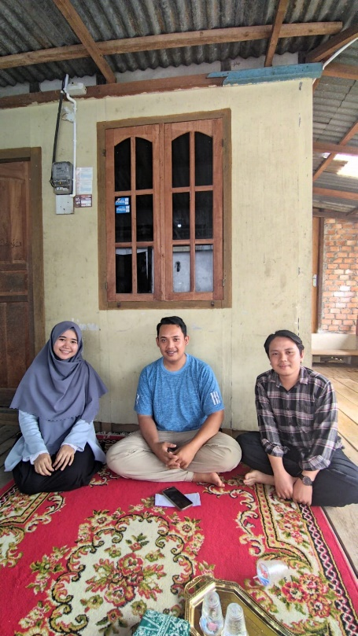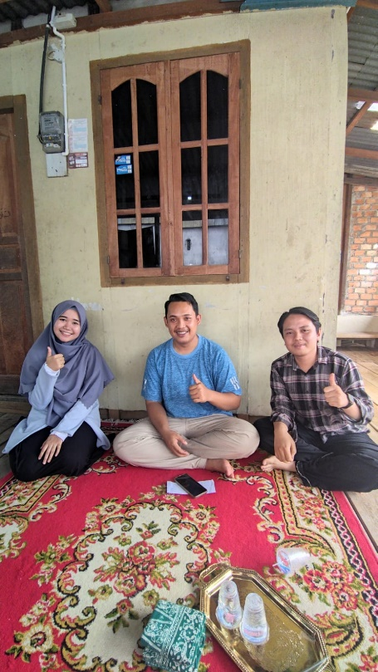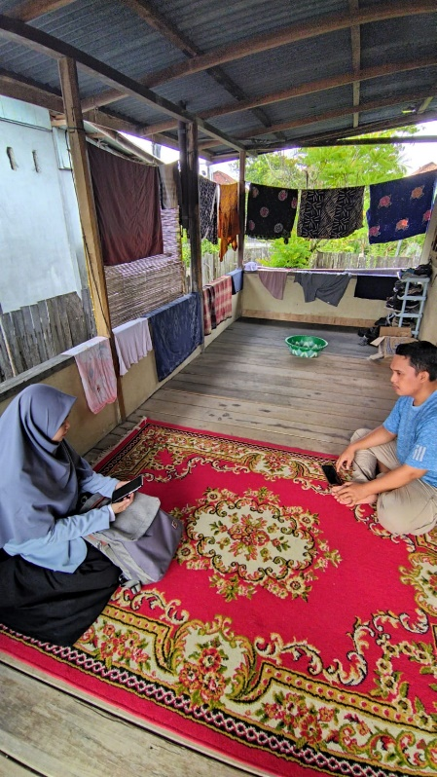

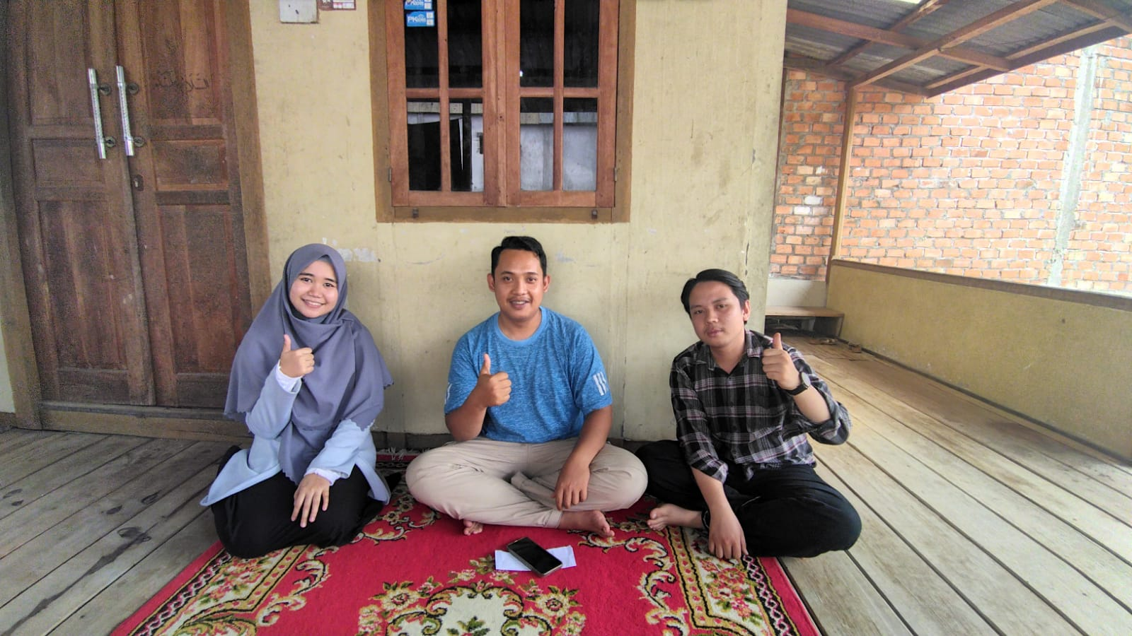

**Ulu Gedong Group**



